3. Prepare UML diagrams.
Prepare Use-case diagram for given project.

Use Case Diagram Guidelines for Better Use Cases
When it comes to analyzing the requirement of a system use case diagrams are second to none. They are visual and usually very easy to understand. The following use case diagram guidelines will help you to create better use cases that are appreciated by your clients and peers alike.
A use case diagram mainly consists of actors, use cases and relationships. More complex larger diagrams can include systems and boundaries. We’ll discuss the use case diagram guidelines based on objects.
It is important to remember that these are use case diagram guidelines and not rules. It’s alright to deviate if it improves the overall quality of the diagram. To get a deep understanding of use case diagrams, check out our use case diagram tutorial.

Actors
- Give meaningful business relevant names for actors – For example, if your use case interacts with an outside organization it’s much better to name it with the function rather than the organization name. (Eg: Airline Company is better than Pan Air)
- Primary actors should be to the left side of the diagram – This enables you to quickly highlight the important roles in the system.
- Actors model roles (not positions) – In a hotel both the front office executive and shift manager can make reservations. So something like “Reservation Agent” should be used for actor name to highlight the role.
- External systems are actors – If your use case is send-email and if interacts with the email management software then the software is an actor to that particular use case.
- Actors don’t interact with other actors – In case actors interact within a system you need to create a new use case diagram with the system in the previous diagram represented as an actor.
- Place inheriting actors below the parent actor – This is to make it more readable and to quickly highlight the use cases specific for that actor.
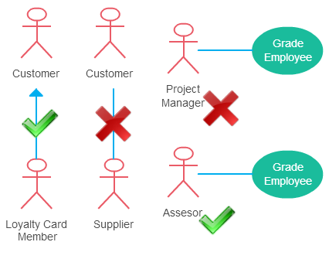
Some things to consider when creating the actor element in use cases

Use Cases
- Names begin with a verb – A use case models an action so the name should begin with a verb.
- Make the name descriptive – This is to give more information for others who are looking at the diagram. For example “Print Invoice” is better than “Print”.
- Highlight the logical order – For example, if you’re analyzing a bank customer typical use cases include open account, deposit and withdraw. Showing them in the logical order makes more sense.
- Place included use cases to the right of the invoking case – This is done to improve readability and add clarity.
- Place inheriting use case below parent use case – Again this is done to improve the readability of the diagram.
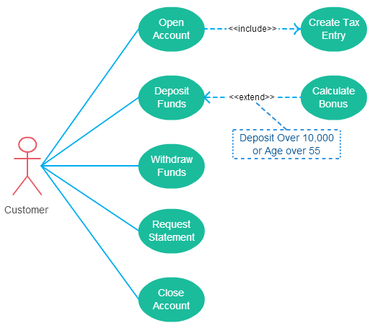
Few things to consider when drawing use cases

Relationships
- Arrow points to the base use case when using <<extend>>
- <<extend>> can have optional extension conditions
- Arrow points to the included use case when using <<include>>
- Both <<extend>> and <<include>> are shown as dashed arrows.
- Actor and use case relationship don’t show arrows.
Check out the link to learn more about use case diagram relationships.

System boundry is not visible.


A use case diagram is "a diagram that shows the relationships among actors and use cases within a system. "Use case diagrams are often used to:
- Provide an overview of all or part of the usage requirements for a system or organization in the form of an essential model or a business model
- Communicate the scope of a development project
- Model your analysis of your usage requirements in the form of a system use case model>
A use case model is comprised of one or more use case diagrams and any supporting documentation such as use case specifications and actor definitions. Within most use case models the use case specifications tend to be the primary artifact with use case diagrams filling a supporting role as the "glue" that keeps your requirements model together. Use case models should be developed from the point of view of your project stakeholders and not from the (often technical) point of view of developers. There are guidelines for:
- Use Cases
- Actors
- Relationships
- System Boundary Boxes

1. Use Cases
A use case describes a sequence of actions that provide a measurable value to an actor. A use case is drawn as a horizontal ellipse on a UML use case diagram, as you see in Figure 1.
- Use Case Names Begin With a Strong Verb
- Name Use Cases Using Domain Terminology
- Place Your Primary Use Cases In The Top-Left Corner Of The Diagram
- Imply Timing Considerations By Stacking Use Cases. As you see in Figure 1, the use cases that typically occur first are shown above those that appear later.
Figure 1. Implying timing considerations between use cases.
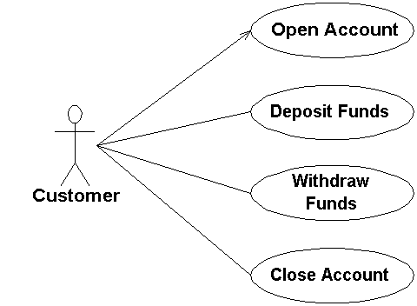

2. Actors
An actor is a person, organization, or external system that plays a role in one or more interactions with your system (actors are typically drawn as stick figures on UML Use Case diagrams).
Figure 2. Online shopping.
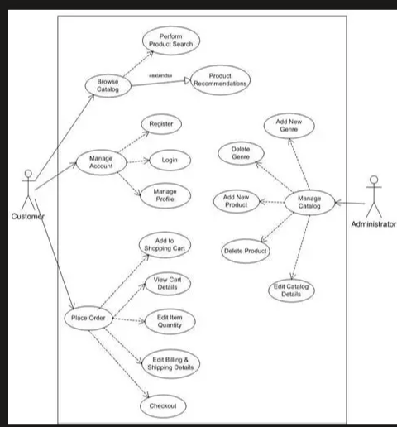
- Place Your Primary Actor(S) In The Top-Left Corner Of The Diagram
- Draw Actors To The Outside Of A Use Case Diagram
- Name Actors With Singular, Business-Relevant Nouns
- Associate Each Actor With One Or More Use Cases
- Actors Model Roles, Not Positions
- Use <> to Indicate System Actors
- Actors Don’t Interact With One Another
- Introduce an Actor Called "Time" to Initiate Scheduled Events

3. Relationships
There are several types of relationships that may appear on a use case diagram:
- An association between an actor and a use case
- An association between two use cases
- A generalization between two actors
- A generalization between two use cases
Associations are depicted as lines connecting two modeling elements with an optional open-headed arrowhead on one end of the line indicating the direction of the initial invocation of the relationship. Generalizations are depicted as a close-headed arrow with the arrow pointing towards the more general modeling element.
Figure 3. Enrolling students in a university.
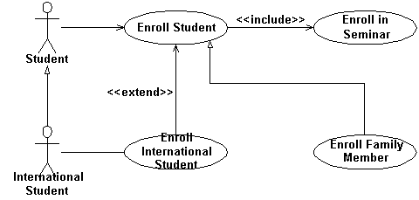

- Indicate An Association Between An Actor And A Use Case If The Actor Appears Within The Use Case Logic
- Avoid Arrowheads On Actor-Use Case Relationships
- Apply <> When You Know Exactly When To Invoke The Use Case
- Apply <> When A Use Case May Be Invoked Across Several Use Case Steps
- Introduce <> associations sparingly
- Generalize Use Cases When a Single Condition Results In Significantly New Business Logic
- Do Not Apply <>, <>, or <>
- Avoid More Than Two Levels Of Use Case Associations
- Place An Included Use Case To The Right Of The Invoking Use Case
- Place An Extending Use Case Below The Parent Use Case
- Apply the "Is Like" Rule to Use Case Generalization
- Place an Inheriting Use Case Below The Base Use Case
- Apply the "Is Like" Rule to Actor Inheritance
- Place an Inheriting Actor Below the Parent Actor

4. System Boundary Boxes
The rectangle around the use cases is called the system boundary box and as the name suggests it indicates the scope of your system - the use cases inside the rectangle represent the functionality that you intend to implement.
- Indicate Release Scope with a System Boundary Box. In Figure 2 you see that three system boundary boxes are included, each of which has a label indicating which release the various use cases have been assigned to.
- Avoid Meaningless System Boundary Boxes.

